Lab # 4 — Assessment Worksheet

**Course Name and Number: FRS301**

**Student Name: Tran Thanh Tuan**

**Student Id: SE161095**

**Instructor Name: Nguyen Van Vinh**

## **Create Virtual Hard Drive, Delete File, Recover File**

***Log into WXP-SP2***

1. **Start VMware Player**

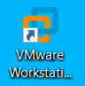

1. **Start Up WXP-SP2**

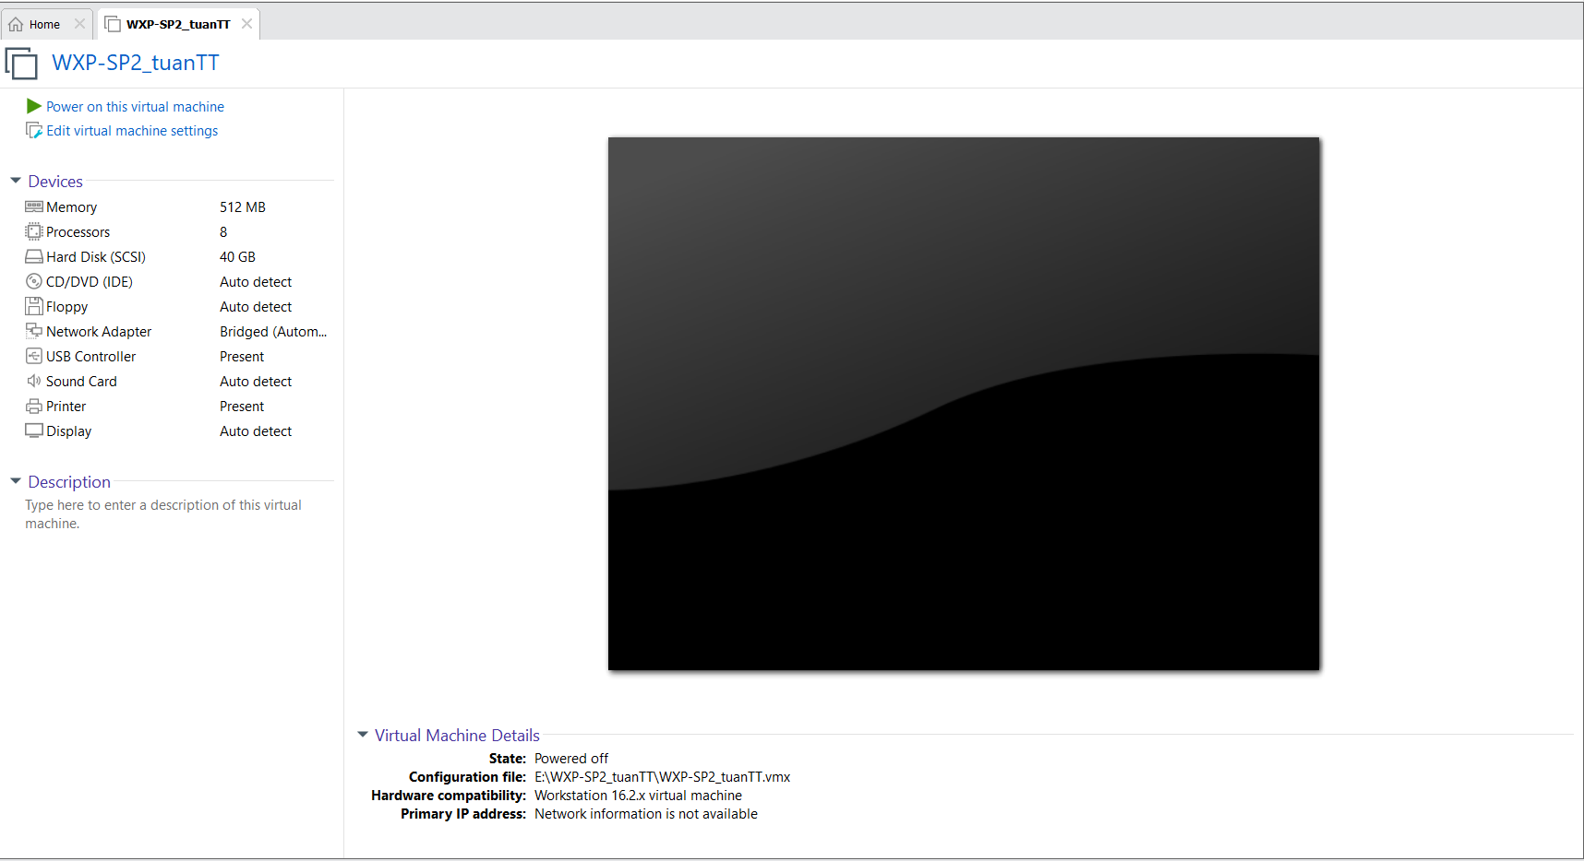

1. **Play Virtual Machine**



1. **Open a Command Prompt**



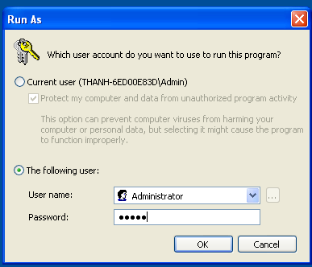

1. **Obtain WXP-SP2's IP Address**

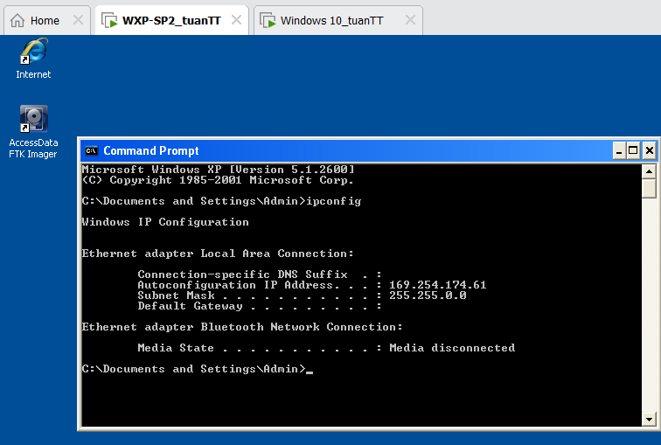

***Download Test Picture***

1. **Start Test Picture Download**

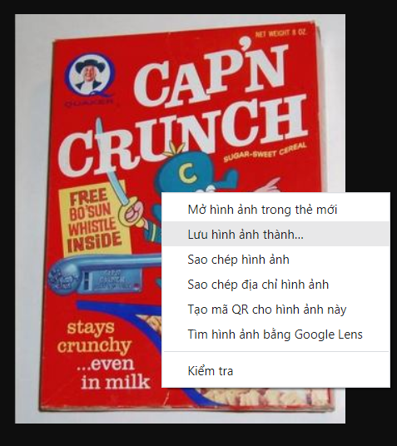

1. **Save Test Picture Download**

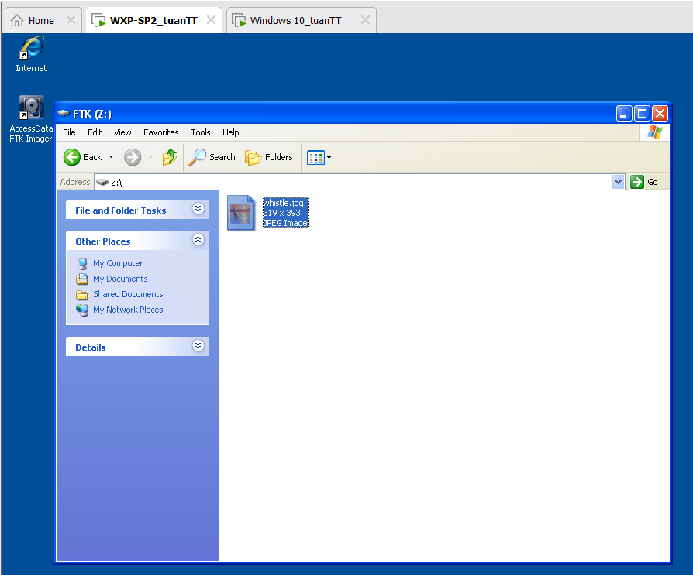

1. **Delete the Test Image**

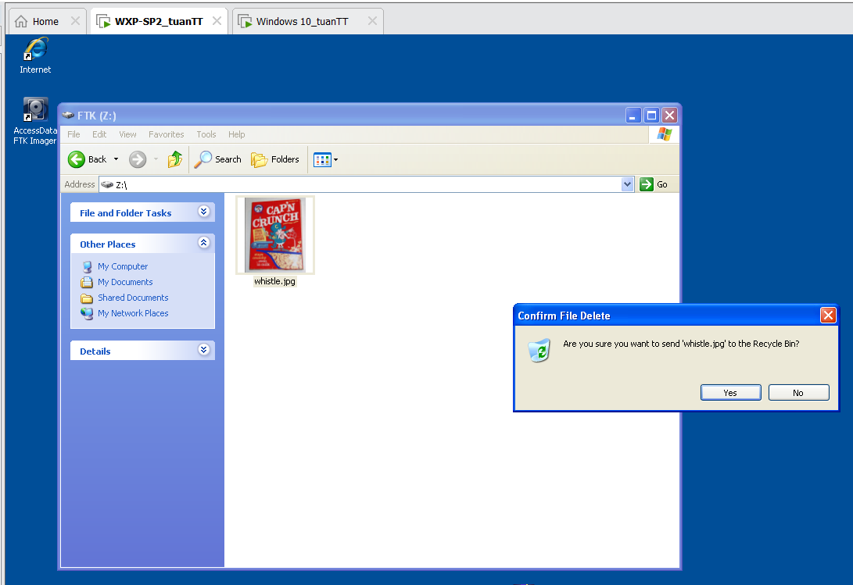

1. **Delete the Test Picture From the Recycle Bin**

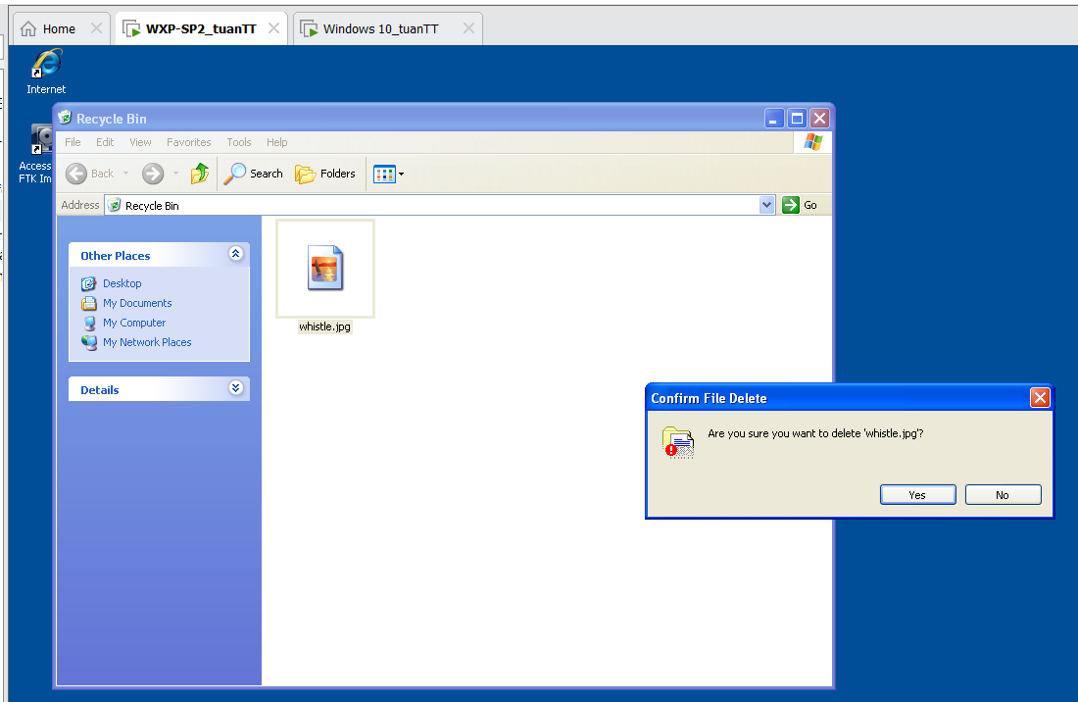

***Forensics Directory***

1. **Create a Forensics Directory**

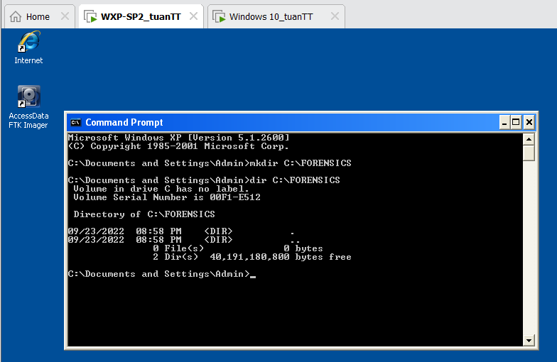

***Start FTK Imager***

1. **Start FTK Imager**

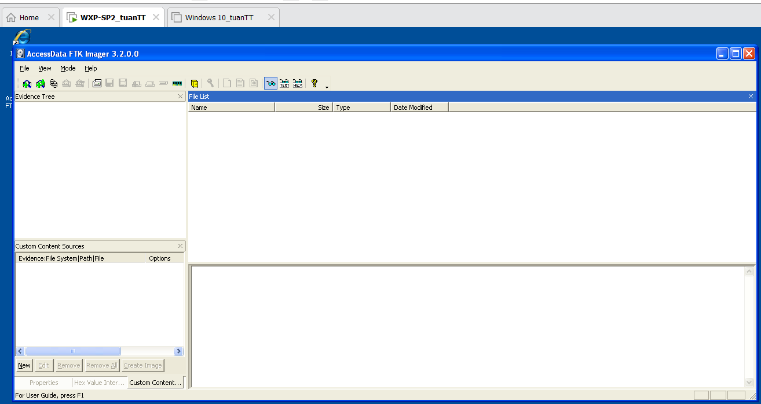

***FTK Imager: Add Evidence Item***

1. **Add Evidence**

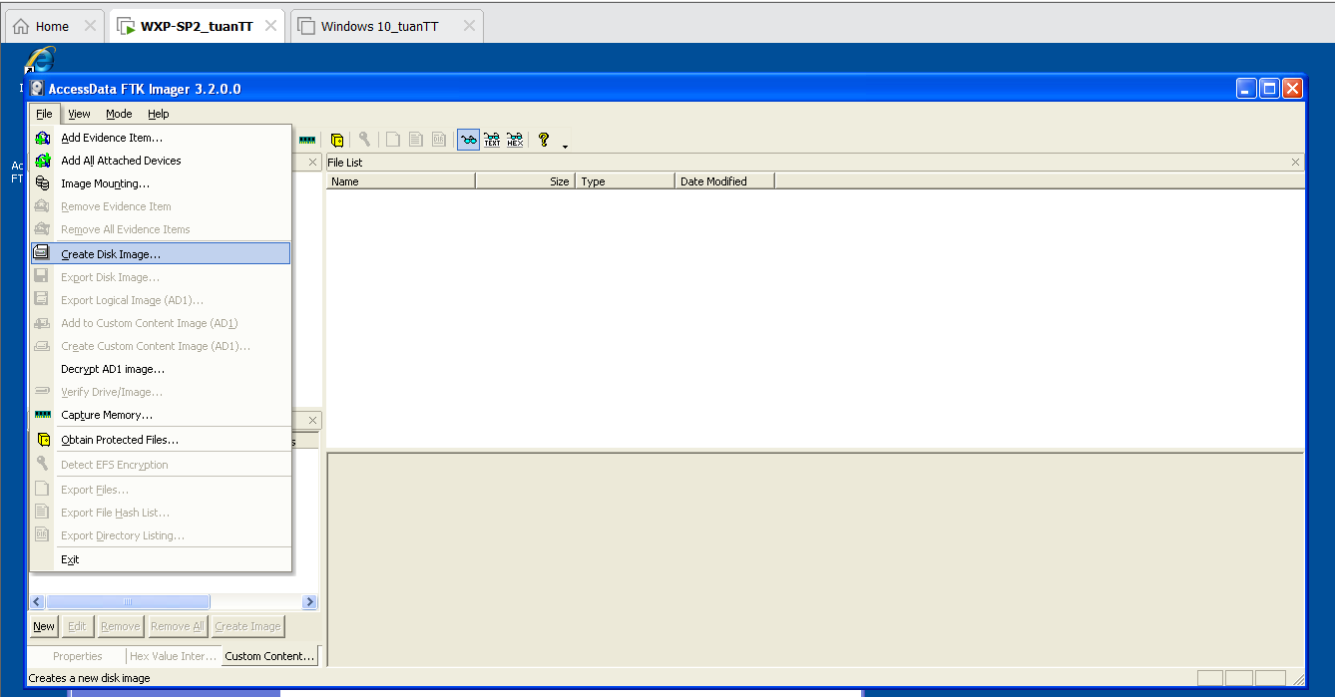

1. **Select Source**

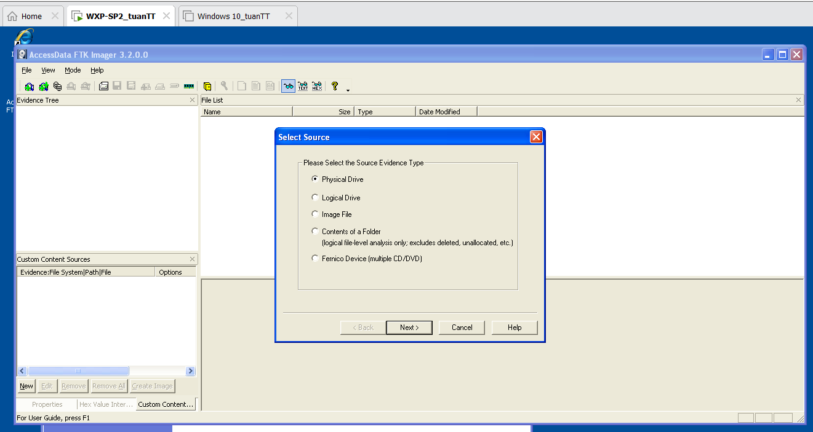

1. **Select Drive**

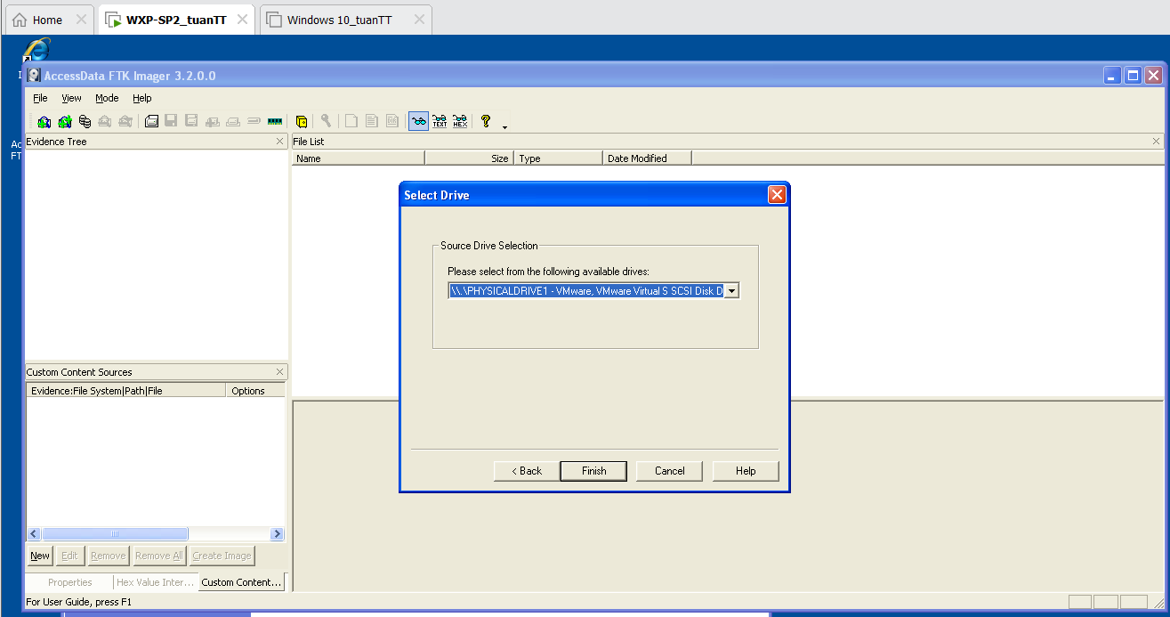

1. **Create Image**

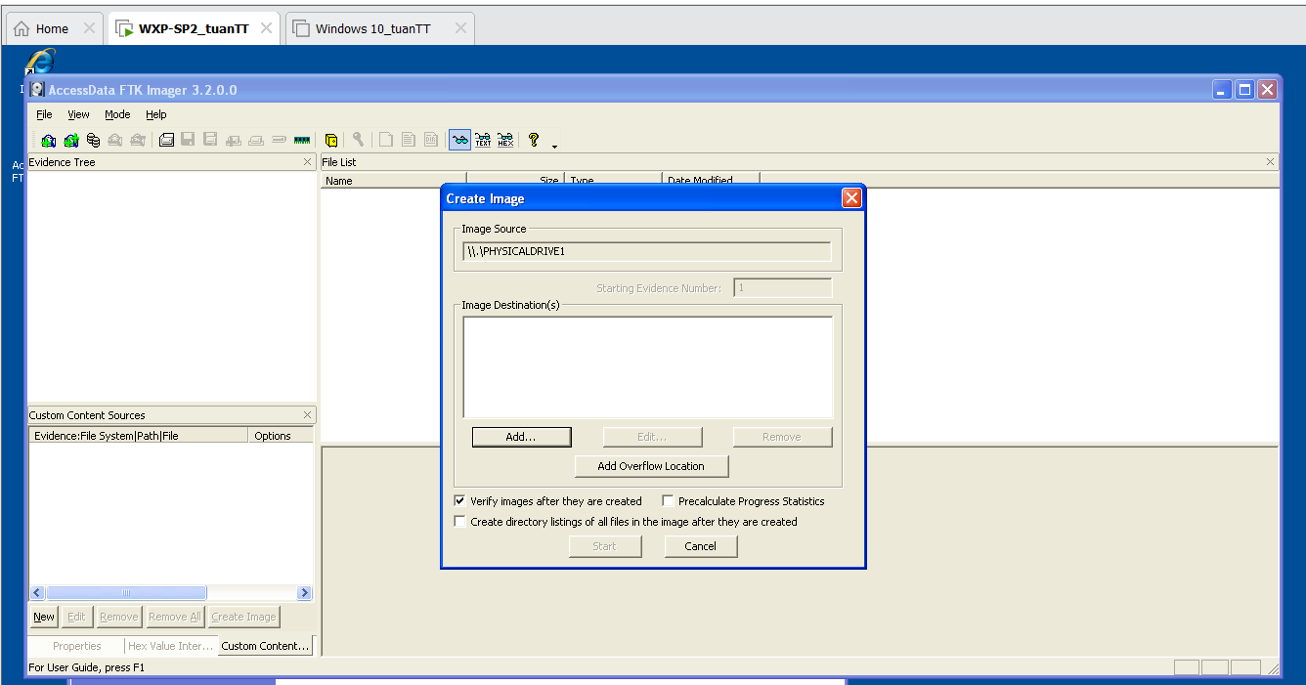

1. **Select Image Type**

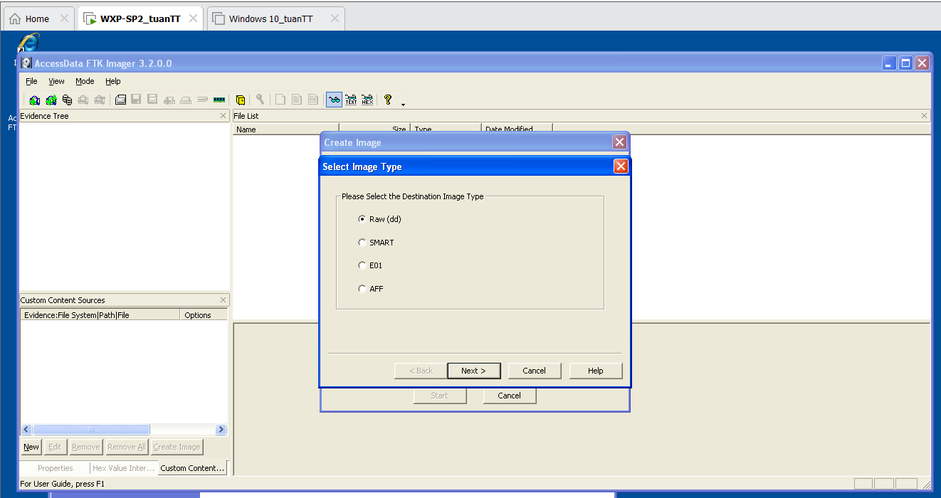

1. **Evidence Item Information**

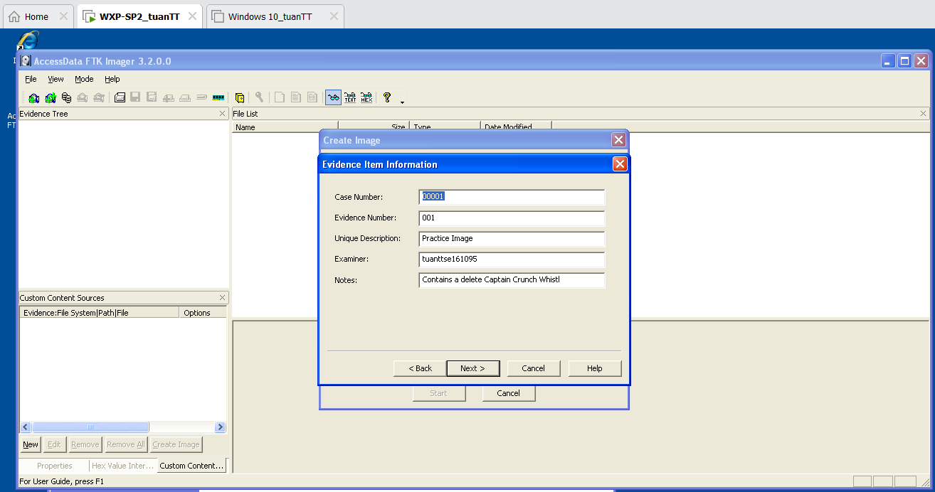

1. **Select Image Destination**

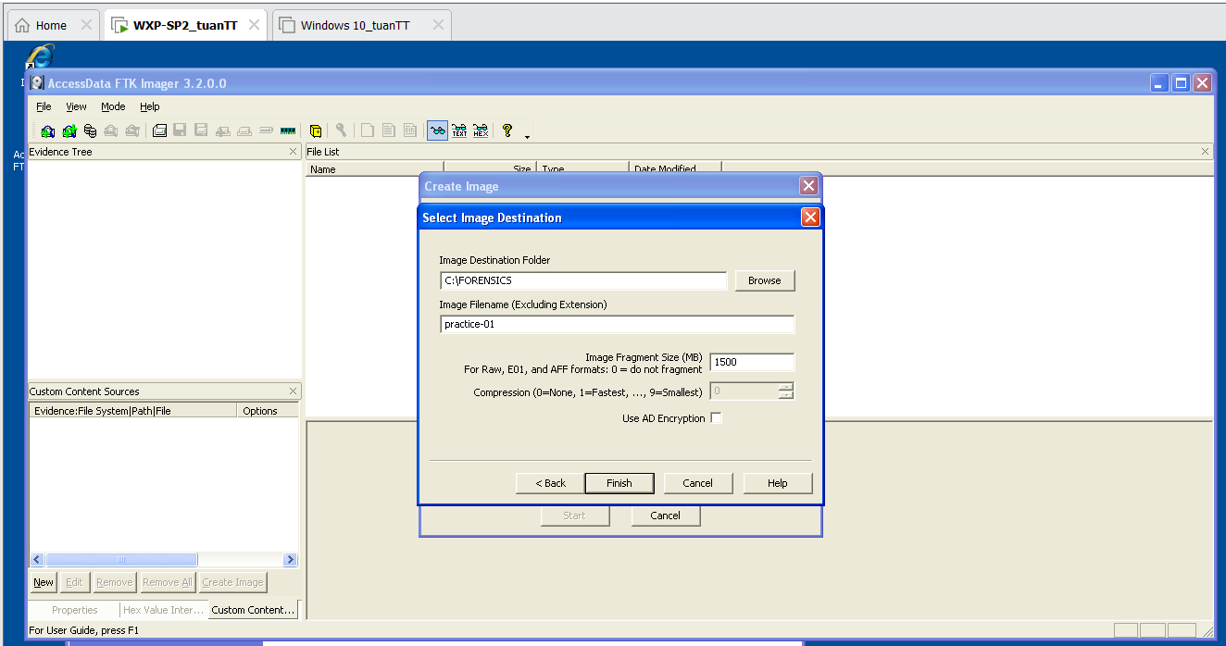

1. **Create Image**

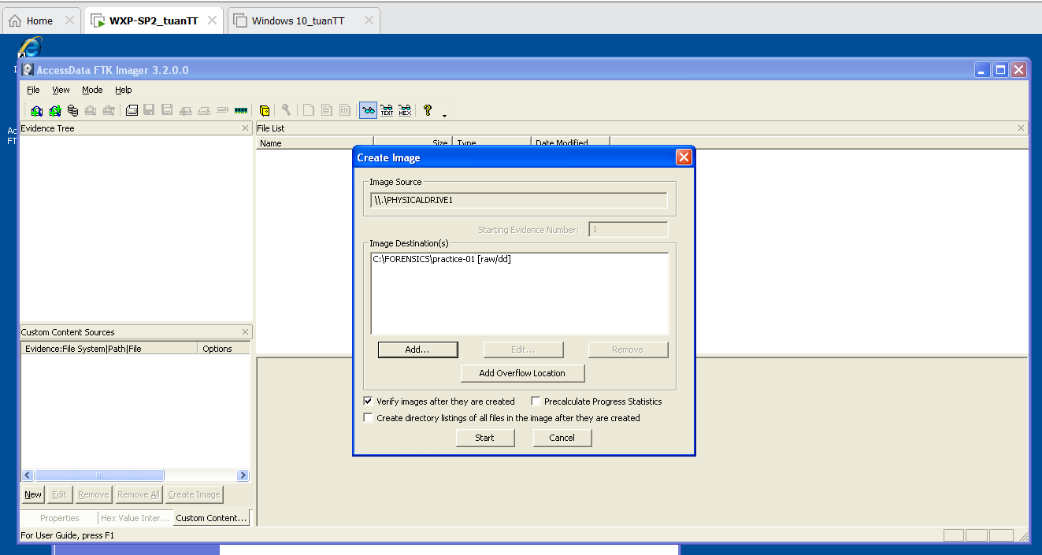

1. **Drive/Image Verify Results**

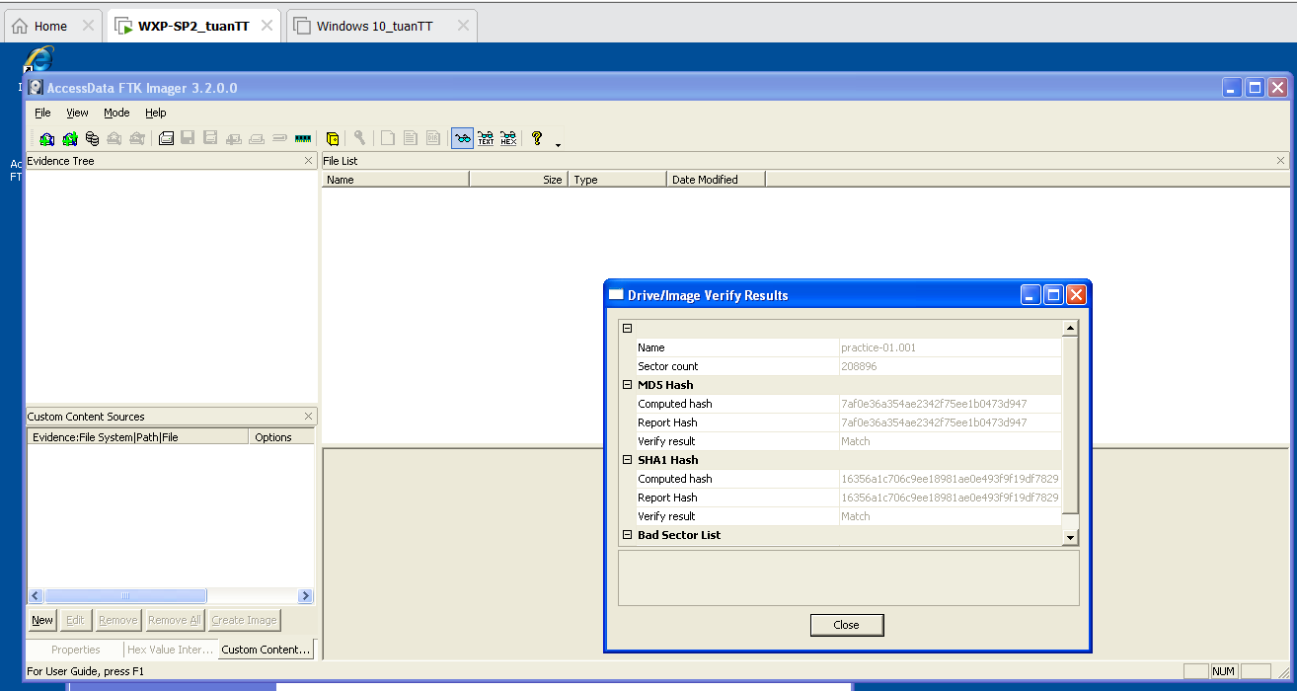

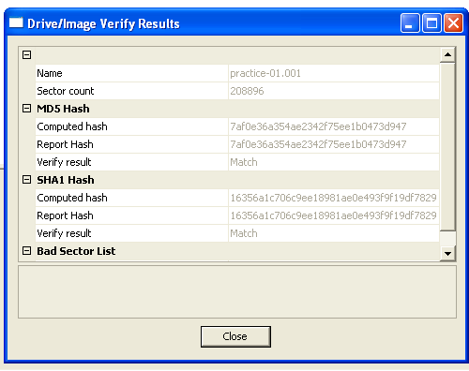

1. **Image created successfully**

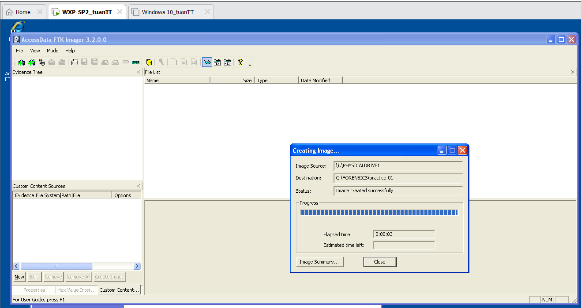

***Proof of Lab***

1. **Proof of Lab**

